Biology: 14. Excretion
Please remember to photocopy 4 pages onto one sheet by going A3→A4 and using back to back on the photocopier
Syllabus
OB20 State the function of the urinary system; describe its structure, identifying the bladder, renal artery, renal vein, ureter, urethra and kidney

OB21 Name the products of excretion: CO₂, water and urea

OB22 Describe the function of the skin in the excretion of waste products made in the body

OB23 Recall that waste products are removed from the bloodstream by filtration in the kidneys in the form of urine, which contains urea, water and salts, and that urine is stored in the bladder before being released from the body.

Student Notes

Excretion is the removal of waste products from the body

The products of excretion are carbon dioxide, water, salts and urea

Urea is a nitrogen-containing compound (remember that the air which we breath in is mostly nitrogen).

The urinary system

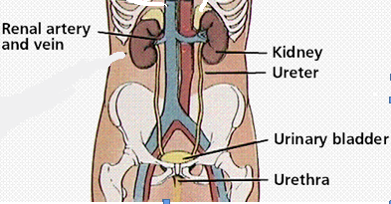

Function of the different parts of the urinary system

Renal artery | Carries blood from the body to the kidneys to be filtered
Kidney | Removes water, salts and urea from the blood to form urine
Renal vein | Carries filtered blood from the kidneys to the heart
Ureter | Tubes which carry urine from the kidney to the bladder
Bladder | Stores urine until it can be released from the body
Urethra | Takes urine from the bladder to outside the body

The Kidneys

Waste products are removed from the bloodstream by filtration in the kidneys.
The waste product produced in this process is called urine.

Urine contains urea, water and salts

The Skin

Water and salts are excreted from the skin in the form of sweat

Did you hear about the mathematician with constipation?
He worked it out with a pencil.

What do kidney stones look like?

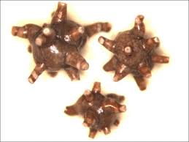 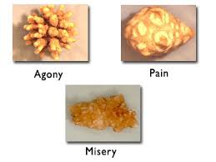
Exam Questions

Eye
Joint
Kidney
Muscle
- [2007 OL]
Choose the correct part of the human body from the list on the right to complete the following sentence.
The _________________ is a human organ of excretion.

- [2009]
- Name the organ shown in the diagram.
- Give the function of the organ shown.

- [2008 OL] [2011 OL]
The diagram shows the human urinary system.
- Name the part labelled A in the diagram.
- What is the function of the part labelled B in the diagram?

- [2008]
How does the composition of the blood in the renal arteries differ from the composition of the blood in the renal veins? Make reference to waste products in your answer.

- [2008]
Account for the difference in the composition of the blood entering and leaving the kidneys.
- [2008]
What is the function of the ureters?

- [2009 OL]
The diagram shows part of the human urinary system.
Answer the following questions on the urinary system.
- Name the parts labelled A and B in the diagram.
- Give one function of part B.
- Name the waste product produced by part A.
- Name one other waste product produced by the human body.

- [2012]
Give the function of five of the six parts labelled.

- [2010] [2010 OL]
Name two waste products that are excreted by our kidneys.

- [2010 OL]
Name a waste product released from the lungs.

- [2007]
Name two substances excreted in sweat.
Exam Solutions
- Kidney

- Name: kidney
- Function: excretion/ make urine/ excrete (remove form the body) water (salts) (urea)...

- A: Kidney
- B: Store urine
- Renal arteries contain waste products.
Renal veins contain no waste products.
- Kidneys remove waste/ urea from the blood.
- Transport urine/ urea/ waste to the bladder

- A = kidney, B = bladder
- Function of B: Stores (holds /collects) urine / releases urine
- Waste Product produced by A: Urine
- Other Waste Product: Urea / sweat / water / salts / carbon dioxide

- Renal artery: brings blood to the kidney
- Kidney: filters blood/ removes waste/ excretes /makes urine/ cleans blood/ helps water balance…
- Renal vein: collects blood from the kidney/ returns blood to body (heart)
- Urethra: carries urine (wastes) (urea) from the kidneys to the bladder
- Bladder: collects (stores) urine
- Urethra: releases urine/. allows sperm to leave
- Water/ salts/ urea.
- Carbon dioxide / water (vapour)
- Water/ salt.

Other Test Questions
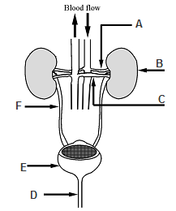
- Label the parts of the urinary system in the diagram.

- Which blood vessel brings waste products into the kidney?

- What is the name of the process that removes waste products from the blood?
Where does it occur?

